Kraków, Poland
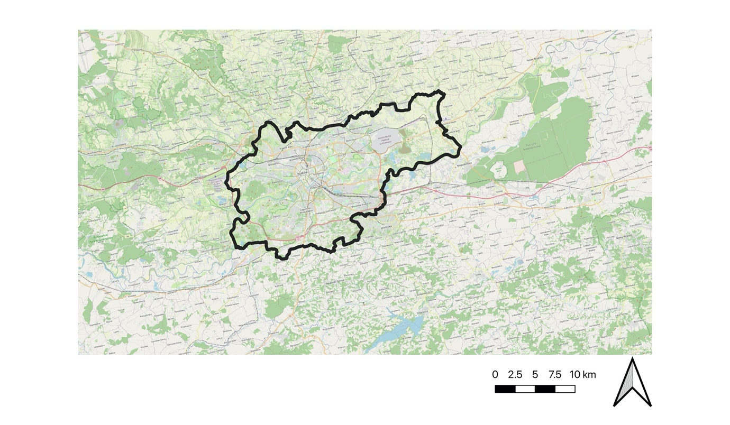
Kraków with its surroundings. City map taken from the document “Directions for the development and management of green areas in Kraków for 2017-2030” and showing different catogeries of green areas in Kraków
Kraków is a strong urban unit with a population of over 800k and a cultural, academic, industrial and touristic center of national significance. It is a part of Metropolia Krakowska - an institutionalized platform of cooperation for Kraków and 14 surrounding municipalities, which main task is to implement Integrated Territorial Investments in the Kraków Functional Area. Kraków benefits from its size, importance, its cultural, creative and social capital as well as from its natural heritage and surroundings. Among the biggest challenges are considerable air pollution, uncontrolled urban sprawl and housing development, shrinking area of the green spaces (often connected to the previous point) and touristification (slowed down by the COVID-19).

State of the Urban Forest. Green spaces and green infrastructure in Kraków were most extensively described in “Directions for the development and management of green areas in Kraków for 2017-2030”. Cities’ forests are mostly covered by the “Powiat Programme to Increase Afforestation in the City of Kraków for the years 2018-2040”. The first one defines cities’ natural system as “consisting of not only arranged green spaces, but also those intended for agriculture, or ones staying unused - postindustrial, postagricultural or natural and semi-natural landscapes”. It also accepts the concept of “third nature” by admitting nature is developing in various locations - housing estates, industrial zones etc, even though the name itself is not used. It also divides cities' green spaces into two categories - public green spaces and contributing green spaces. The first one being a at least partially designed, open for inhabitants and covered in greenery by at least 50%, the second consists of other spaces eg. cemeteries, gardens, allotment gardens, agricultural lands etc. Forests might be divided into two types - regular ones and forest parks and fall in both categories of green spaces, depending on their landscaping and infrastructure.
The main urban forests areas in the city are Bielany-Tyniec Landscape Park (a large terrain of protected nature in the western part of the city borders) and smaller forests scattered around the city eg. Borkowski, Mogilski forest. Other vital elements of a local ecosystem are rivers (Wisla and several smaller ones) and their waterbanks. There are also other significant green spaces - Planty (former fortifications surrounding the old town), Błonia (a large meadow in the centre of the city), as well as city parks and allotment gardens. There are also multiple protected areas, including Nature 2000 programme, smaller parks and green, unused spaces, which also support the local ecosystem.

Governance, planning and policy landscape. At the city and local level the main executive is the city president, who might set his deputies and proxies for specific cases. One of the president’s deputies is focused on sustainable development of the city. The main legislative power is the city council, who approves every decision, plan or strategy of the city. Additionally, every district (18) has its own council who supports the city level government and works on quality of life and needs of their neighbourhoods’ citizens. City is further divided into faculties (27), referees and independent positions, which prepare plans and programmes. Another element of the city government are managements who focus on specific parts of the cities’ infrastructure. The one most important considering blue-green infrastructure is Green Spaces Management (ZZM), which received competences to govern all the parks, forests and generally - green spaces in the city. Before creation of this unit, responsibility for cities’ green spaces was divided between multiple faculties.

There are several spatial planning documents, which might include UF-NBS, for example Study of Conditions and Directions of Spatial Planning and Local Plan of Spatial Development contain information, requirements and programme of green spaces. Local Plan of Adaptation, consisting of study of climate change impact on the city and ways to mitigate and adapt and mentioning greenery on multiple occasions. There is also the “Powiat Programme to Increase Afforestation in the City of Kraków for the years 2018-2040”, which aims to increase forests area in the city by at least 8%. The most notable planning document and initiative in Kraków is the “Directions for the development and management of green areas in Krakow for 2017-2030”. It took the form of a wide cooperation between various city units (which usually have their own strict competencies and do not work together), experts and with use of the social participations methods - workshops with the citizens were organised in every district. The document covers various aspects of blue-green infrastructure in the city - spatial planning, land property, cultural heritage, social necessity of green spaces and their accessibility. It also highlights necessary actions in real estate management, spatial planning and cultural heritage management.

Participation, citizen science & contestation. Participatory governance in Poland has lots of obstacles and it is hard to say that administrators and decision makers are accustomed to conversate with their citizens. The authorities are usually hierarchy based, with strictly divided competences which does not help in involving inhabitants to projects. Social participation is often reduced to limited groups of active inhabitants, projects’ meetings and consultations. There are some initiatives, however, which certainly will help building a cooperation between the city and its citizens. Those connected to NBS are started by Kraków Municipal Greenspace Authority (ZZM) and often focused on activation and education. Another example of social participation in Kraków are consultations of “Development and Management of Greenery in Kraków, 2017-2030”, which included open workshops in every district (18 in total) and a consultation point allowing citizens to learn about, discuss and comment the document.
Kraków also saw many informal movements and actions. They are usually initiated by a local NGO (there are many concerned about nature, public space and pollution) or a group of citizens, who see lacks in their surroundings, or believe the formal paths are too long. Those groups take various approaches, some of them focus on guerilla-like actions, others concentrate on community and policy-making. Some of their actions were made in cooperation with Kraków Municipal Greenspace Authority. An important tool in shaping urban greenery and social participation is the Kraków civic budget (since 2014), in which a high percentage of submitted and financed projects relates to the green areas, which is systematically growing (~5 million PLN in 2015 to ~10 million PLN in 2018).
Socio-economic trends. Kraków is one of main centres of science, tourism and culture. Through the last years several effects of it became more obvious - touristification and gentrification of the old town and uncontrolled urban sprawl. The latter results from high housing demand, but also from growing prices in the city center. It is also a cause of giant investment pressure on green spaces, which are systematically decreasing. Air pollution, created mostly by outdated heating in Kraków, but also wood-based heating in neighbouring municipalities, car traffic and geography (Kraków is located in the river valley). The COVID-19 pandemy slowed down, or even temporarily stopped touristification, the other challenges however will still influence the city in the following years. What is more, the population of Kraków, in which currently lives about 780 thousand people, is growing. This might further increase investment pressure on the greenspaces, current tendencies of the citizens to participate in local governance and expectations of greener policies may influence this trend.

Major challenges:
- The conflicts of interest, both humans-humans and nature-humans. The strong conflicts between different stakeholders with opposing interests. The current and future investments in green areas (especially River Parks) and making them available to users create the risk of their degradation (noise, light pollution, littering, destroying plants, etc.).
- The problems with the enforcement of local law, especially municipal spatial development plans, resulting in too intensive development and a lack of biologically active areas.
- “Silosity” of city management; too many institutions responsible for the urban green areas and the protection of urban ecosystems, their dispersed and unclear responsibilities, lack of coordination and a coherent strategy. Limited cooperation between the municipality and stakeholders, as well as between various social groups.
- The degradation of environment in Kraków, low quality of surface water, very low quality of air (smog), some strongly degraded brown-fields.
- The lack of tradition and models of involving business and private owners in the protection of urban green areas; high resistance to comprehensive regulations ensuring effective protection of trees and plants in private lands; problems with making certain green areas available (e.g. monasteries and churches, housing estates, schools and universities).

Knowledge gaps:
- The methods of creating and maintaining the protected green areas (e.g. the River Parks) to balance their ability to be used by citizens and their effective protection, without losing biodiversity. The rules of making them available and using them.
- How to build the public awareness on the value of green areas and ecosystem services, how to influence reasonable needs and expectations of various groups of stakeholders.
- The complex and efficient tools and regulations of spatial planning).
- The methods of precise evaluation and determination of ecological continuity; taking into account and balancing all types of continuity (needs of various species of plants and animals, hydrological, city ventilation, alternative forms of transport, etc.).

